305
HUMIDITY&TEMP METER

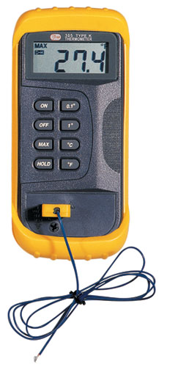

1. Max. Display:1999
2. Measuring Range: -50℃~1300℃
-58℉~1999℉
3. Resolution: 0.1℃(-50℃~199.9℃)
1℃ (-50℃~1300℃)
0.1℉(-58℉~199.9℉)
1℉ (-58℉~1999℉)
4. Accuracy: ±0.3% ±1℃ (-50℃~1000℃)
±0.5% ±1℃ (1000℃~1300℃)
±0.3% ±2℉ (-58℉~1999℉)
5. Data Hold
6. MAX
7. Full Icon Display
8. Low Battery Display
9. Power: 9V Battery (NEDA 1604 or 6F22)
10. Sensor Type: K Type

