306
HUMIDITY&TEMP METER

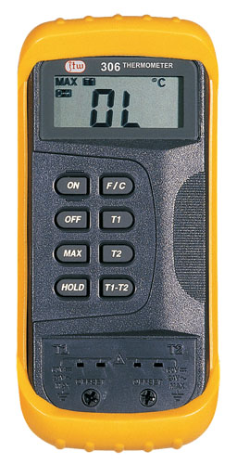

1. Max. Display:1999
2. Measuring Range: -50℃~1300℃
-58℉~1999℉
3. Resolution:1℃ (1℉)
4. Accuracy: ±2℃ (-50℃~0℃)
±0.3% ±1℃ (0℃~1000℃)
±0.5% ±1℃ (1000℃~1300℃)
±4℉ (-58℉~32℉)
±0.3% ±2℉ (32℉~1999℉)
(T1-T2) Measurements Accuracy:
℃:0.3%(T1-T2) ±2℃
℉:0.3%(T1-T2) ±3℉
5. Data Hold
6. MAX
7. Full Icon Display
8. Low Battery Display
9. Power: 9V Battery (NEDA 1604 or 6F22)
10. Sensor Type: K Type

