309
Thermo-Hygrometer
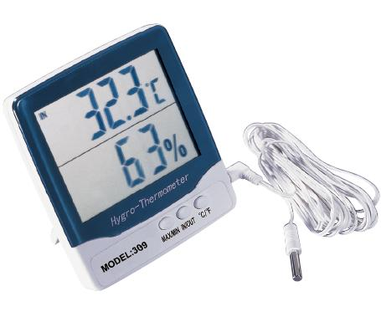

1. Temperature measure range:
Indoor temperature measure range:
-50°C~+70°C (-58°F~+l58°F)
Outdoor temperature measure range:
-50°C~+70°C (-58°F~+l58°F)
2. Temperature resolution:0.1°C (0.2°F)
3. Temperature accuracy: ±1.0°C
5. Humidity measure range: 20%RH ~ 90%RH.
6. Humidity resolution: 1%
7. Humidity accuracy: ± 5%RH
8. Power: 1.5V (AAA battery)
9. Standard Quantity Per Carton: 100PCS
10. Carton Measurement : 58*34*29 cm
11. Carton Gross Weight: 15kgs

