9606EX Thermo-Hygrometer 溫濕度計
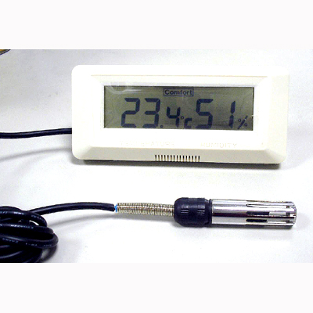

SPECIFICATION:
Temperature Range -50 ~ +70 °C (-58 °F ~ +158 °F)
Resolution 0.1
Accuracy ± 0.5 °C (0 ~ +40 °C),
±1 °C (The remainder range)
Humidity Range 10 % RH to 95 % RH
Resolution 1 %
Accuracy ± 3 % (30 % RH ~ 80 % RH),
± 5 % (The remainder range)
LCD Display Size 95 x 25 mm
Dimension 140 x 60 mm
°C/°F by Soldering Options
Low Battery Indicator
Wall Mounting & Table Standing
Battery Size AAA 1.5V x 2 (Included)
External Combination Probe with 1 M cable for temperature and humidity

