CTH-168
Thermometer & Hygrometer with Alarm Clock

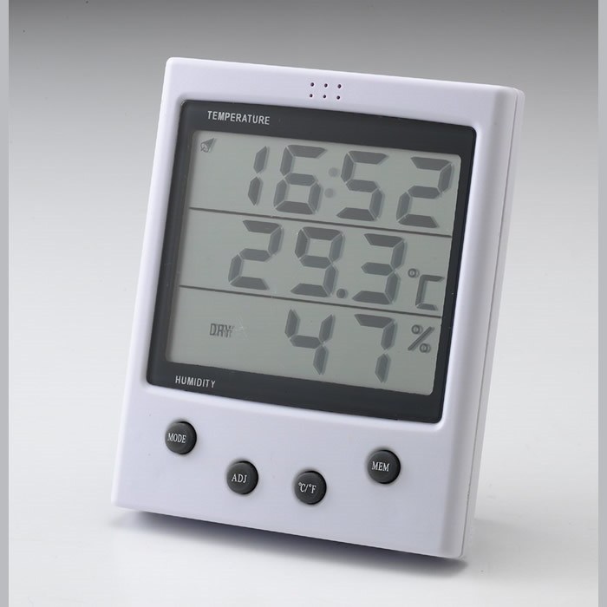

Specification :

* Temp. Range: -10 to +50℃ (+23℉ to +122 ℉) with 0.1 resolution
Accuracy: +/- 0.5 ℃ (0 - 40 ℃), +/- 1℃ (the remainder range)
* Humidity Range: 15 – 95% with 1% resolution
Accuracy: +/- 3% (30% - 80%), +/- 5% (the remainder range)
* Function Key: MODE, ADJ, ℃/℉, MEM
* Clock (12 or 24 hour selectable) with snooze alarm function.
* Clock alarm with beep each full hour
* With COMFORT / DRY / WET Index
COMFORT icon will display when 65%＞Humidity ＞40%
and 25℃＞Temp＞20℃
DRY icon will display when Humidity ＜ 40%
WET icon will display when Humidity ＞ 65%
* Wall Mounting & Desk Display
* Unit Size: (W) 102.8mm x (H) 121.7mm x (T) 20.5mm
* Battery: Size AAA 1.5 V x 1 (included)

