HP-101A-B13
Roller Probes
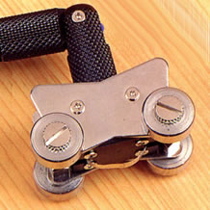

Model Number
HP-101B-B13

Maximum Temperature
250℃

Response Time
3"

Applications
For measuring wires, cables, coils.

Remarks
swivel head

