HP-102A-B11
Roller Probes
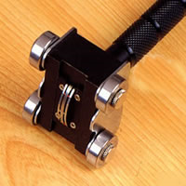

Model Number
HP-102A-B11

Maximum Temperature
250℃

Response Time
3"

Applications
For measuring wires, cables, coils.

Remarks
straight head

