HP-102A-B13
Roller Probes

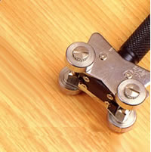

Model Number
HP-102A-B13

Maximum Temperature
250℃

Response Time
3"

Applications
For measuring wires, cables, coils.

Remarks
straight head

