HP-102A-T21
Roller Probes

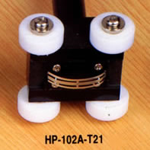

Model Number
HP-102A-T21

Maximum Temperature
250℃

Response Time
3"

Applications
For measuring wires, cables, coils.

Remarks
straight head

