HP-202A-B23N
Magnetic Probes

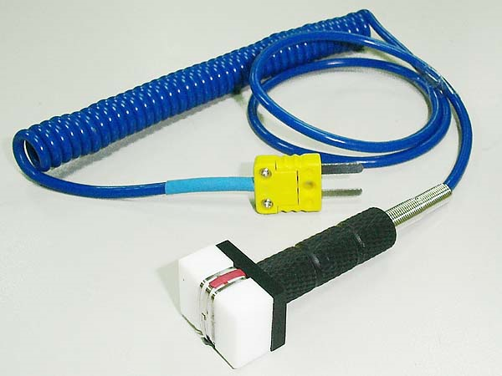

Model Number
HP-202A-B23N

Maximum Temperature
250℃

Response Time
2"

Applications
For measuring magnetic surfaces; such as: motors, driers, blast furnaces, transformers, heating elements. For measuring wires, cables, coils.

Remarks
straight head

