HP-402A-M13
Surface Probes
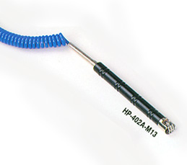

Model Number
HP-402A-M13

Maximum Temperature
400℃

Response Time
2"

Applications
For measuring stationary surfaces; such as: molds, textiles, packages, prints, pc boards, papers, electronic elements.

Remarks
straight head

