HP-403A- M38
Surface Probes
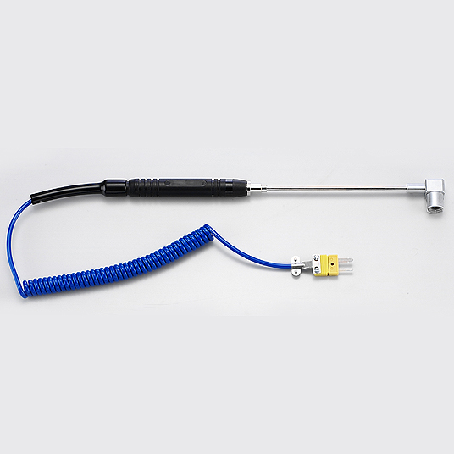

Model Number
HP-403A-M38

Maximum Temperature
500℃

Response Time
3"

Applications
For measuring stationary surfaces; such as: molds, textiles, packages, prints, pc boards, papers, electronic elements.

Remarks
Right-angle head

