HP-404A- M38
Surface Probes

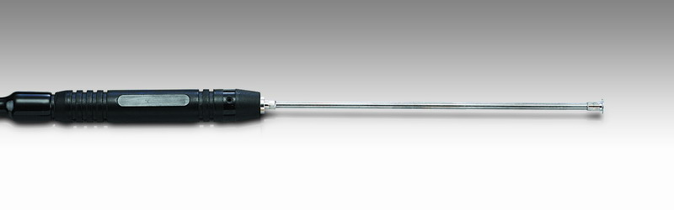

Model Number
HP-404A-M38

Maximum Temperature
500℃

Response Time
3"

Applications
For measuring stationary surfaces; such as: molds, textiles, packages, prints, pc boards, papers, electronic elements.

Remarks
extra long head

