HP-404A-T21
Surface Probes

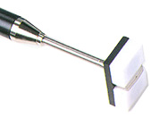

Model Number
HP-404A-T21

Maximum Temperature
250℃

Response Time
3"

Applications
For measuring stationary surfaces; such as: molds, textiles, packages, prints, pc boards, papers, electronic elements.

Remarks
extra long head

