HP-404A-T23
Surface Probes

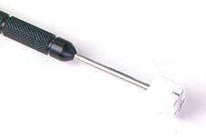

Model Number
HP-404A-T23

Maximum Temperature
250℃

Response Time
2"

Applications
For measuring stationary surfaces; such as: molds, textiles, packages, prints, pc boards, papers, electronic elements.

Remarks
extra long head

