HP-405A-M12
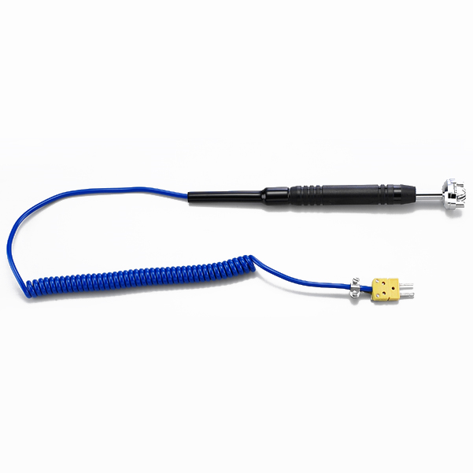
Surface Probes

Model Number
HP-405A-M12

Maximum Temperature
600℃

Response Time
3"

Applications
For measuring stationary surfaces; such as: molds, textiles, packages, prints, pc boards, papers, electronic elements.

Remarks
extra long head

