HP-602A-M11
Air Probes

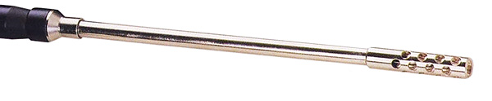

Model Number
HP-602A-M11

Maximum Temperature
600℃

Response Time
3"

Applications
For measuring air, gases, freezers, ovens, fans.

Remarks
Probe:∮8mm x L 138mm

Air Hole Tube:
∮10mm x L 48mm

