HP-602A-S11
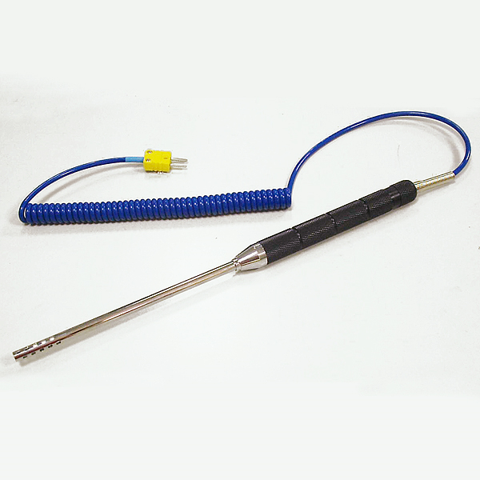
Air Probes

Model Number
HP-602A-S11

Maximum Temperature
600℃

Response Time
3"

Applications
For measuring air, gases, freezers, ovens, fans.

Remarks
Probe :∮6.3mm x L 145mm

