HP-602B-C18
Surface Probes
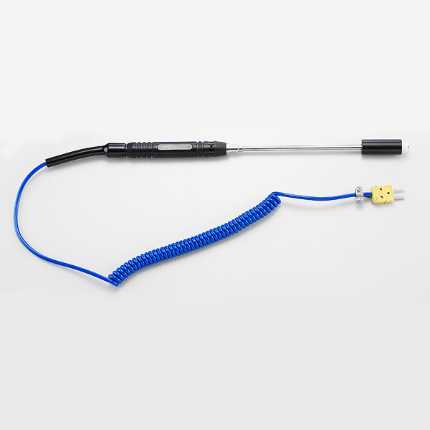

Model Number
HP-602B-C18

Maximum Temperature
800℃

Response Time
3"

Applications
For measuring small surface areas; such as: integrated circuits, transistors, transformers.

Remarks
compact tip

