HP-602C-M13
Surface Probes

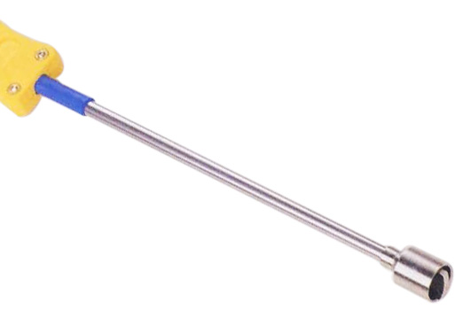

Model Number
HP-602C-M13

Maximum Temperature
500℃

Response Time
2"

Applications
For measuring small surface areas; such as: integrated circuits, transistors, transformers.

Remarks
compact tip

