HP-603B-C11
Surface Probes

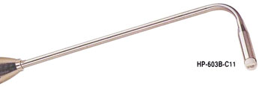

Model Number
HP-603B-C11

Maximum Temperature
600℃

Response Time
2"

Applications
For measuring flat stationary surfaces; such as: molds, electronic elements, heating elements.

Remarks
coil sensor

