HP-603C-T13
Surface Probes

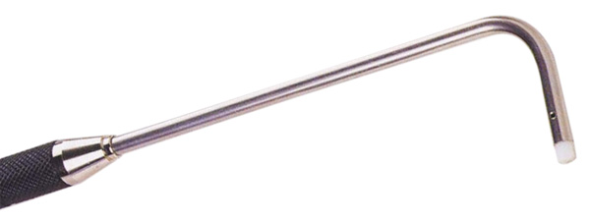

Model Number
HP-603C-T13

Maximum Temperature
250℃

Response Time
2"

Applications
For measuring small surface areas; such as: integrated circuits, transistors, transformers.

Remarks
compact tip

