T-48W Thermometer Module with Outdoor Sensor
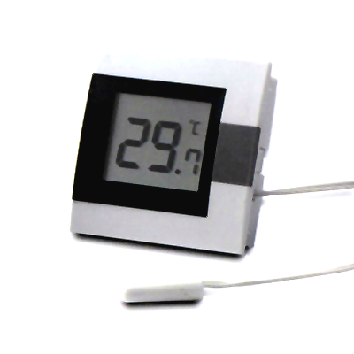

SPECIFICATION:

Measuring Range : -10 ~ +50˚C (+23˚F~+122˚F)
Resolution : 0.1
Accuracy : ±0.5˚C (0-40˚C),
±1˚C (the remainder range)
˚C or ˚F by option
Outdoor sensor with 3M cable for temperature
Unit Size : 52.2mm × 52.2mm × 17mm (W) x (H) x (T)
Panel Cut-Out Size : 47.7mm x 47.7 mm x 12mm (W) x (H) x (T)
Battery : 1.5V Vinnic L1154 x 1 or Equivalent (included)

