TH-48MEX Thermo-Hygrometer Module (with Memory Function)
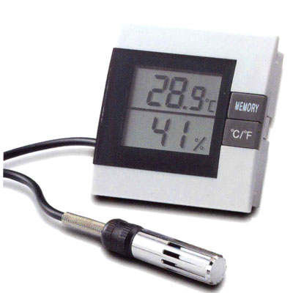

SPECIFICATION:

Temperature Range : -10 ~+ 50 °C (+14 ~+122 °F)
Resolution : 0.1
Accuracy : ± 0.5 °C (0-40 °C)
±1 °C (The remainder range)
Humidity Range : 15- 95%
Resolution : 1%
± 3% (30 %-80 %),
± 5% (The remainder range)
Function Key : Memory. °C/°F
Memory function for humidity only
Panel Mounting
Unit Size : 52.2 mm × 52.2 mm × 17 mm (W) x (H) x (T)
Panel Cut-Out Size : 47.7 mm × 47.7 mm × 12 mm (W) x (H) x (T)
Battery : 1.5V VINNIC L1154 x 1 or Equivalent (included)
With memory function and combination probe

