TH-812 Thermo-Hygrometer 溫濕度計
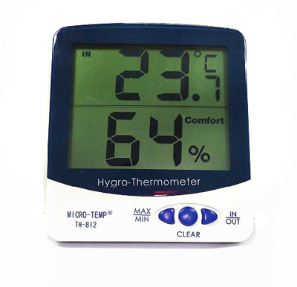

SPECIFICATION:
Measuring Range
Temperature -10 ~50 °C (+14 ~ 122 °F)
Accuracy ± 1°C
Humidity 20 ~99 % RH
Accuracy ± 3 % RH
Battery 1 x 1.5 V AAA size
LCD Size 63 (L) x 78 (W) mm
Product Size 109 (L) x 98 (W) x 21 (T) mm

Function:
Display indoor temperature & humidity
Record maximum and minimum temperature and humidity
Selectable: °C or °F display
Max/Min memory function
Flip out stand and wall mount

