TS-15A
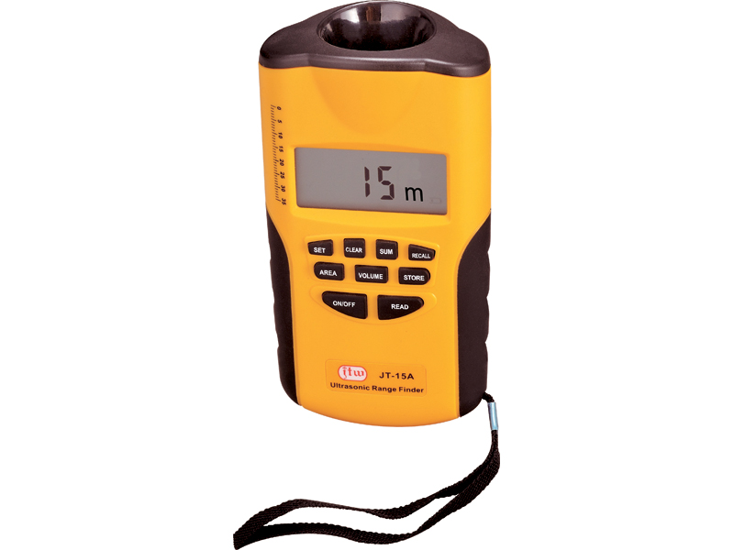
Ultrasonic Range Finder

Professional Electronic Measuring Tool
With Receiver And Target
Instant, convenient and accurate to 99.5%
at distances from 0.6m to 60m (max 75m)
2 WAYS TO MEASURE: RECEIVE ALONE TO 15M(MAX 18M).
Receiver to Target tom (max 75m)
Stores up to 5 measurements
For indoor or outdoor use
Can be field calibrated
RANGE WITHOUT TARGET:
Min: 1ft 11 ins(0.6m)
Max: 59ft(18m)
Typical: 1ft 11 ins to 49 ft(0.6m to 15m)
Actual: Will vary depending on environmental conditions
RANGE WITH TARGET:
Min: 3 ft 3 ins(1m)
Max: 246 ft(75m)
Typical: 3 ft 3ins to 197 ft(1m to 60m)
Actual: Will vary depending on environmental conditions
ACCURACY:
Single Unit Mode:99.5% (±1/4 in or ±1m)
Dual Unit Mode:99.5% (±1/2 in or ±1m)
These accuracies are possible when environmental conditions are as follows:
Temperature: 32 to 86℉ (0 to 30℃)
Relative Humidity: 30 to 70%
Altitude: -328 ft to +328 ft(-0.1 to 0.1km)
Wind Speed: Still Air

