TS-520C
INFRARED THERMOMETER
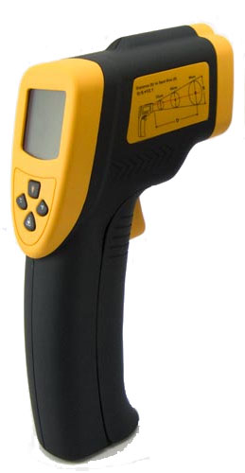

1. Back light and laser pointer on/off option
2. Auto power off
3. Low battery indication
4. Measuring range: -40℃~550℃
5. Auto data hold
6. Accuracy: ± 2℃
7. ℃/℉ selectable
8. Distance:Spot=8:1
9. Max,Min,Dif., Ave measurement

