TS8901
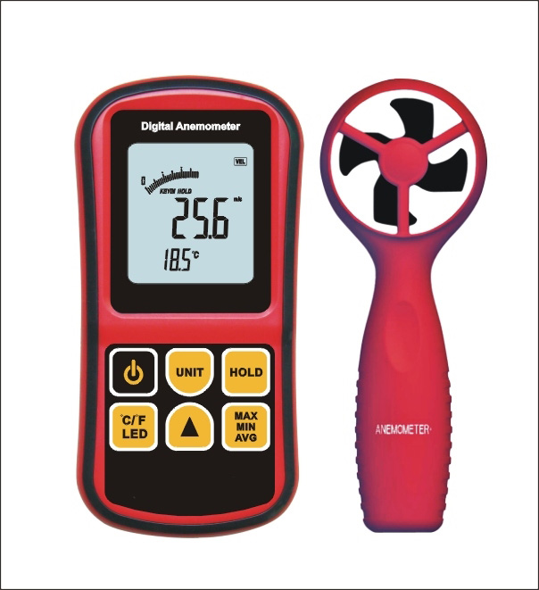

GENERAL FEATURE & SPECIFICATION
Measuring Range :0-45℃
Wind Speed measuring Range :0.3-45m/s
Accuracy of temperature: ±2℃
Accuracy of Wind speed:±3%±1dgts
Wind Speed unit selection: m/s,ft/min,knots,km/hr,Mph
Resolution:0.1m/s 0.2℃
Auto/Manual power off
Air Velocity/Air Flow selection
Back light Display
Max/Min wind speed measuring
Average and current wind speed
℃/℉ selection
Data hold function
Size: 145*71*29mm

