TS8908
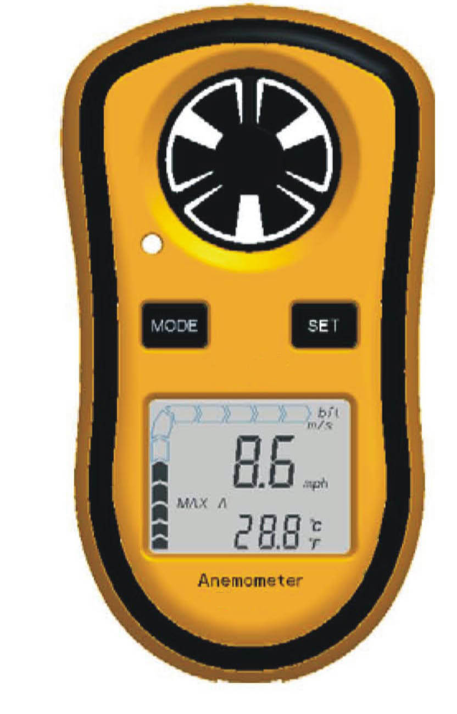
GENERAL FEATURE & SPECIFICATION
Measuring Range :-10-45℃
Wind Speed measuring Range :0.3-30m/s
Accuracy of temperature: ±2℃
Accuracy of Wind speed:±5%
Wind Speed unit selection: m/s,ft/min,knots,km/hr,Mph
Resolution:0.1m/s 0.2℃
Auto/Manual power off
Max/Min wind speed measuring
Average and current wind speed
Size:105*55*20mm

